SQL and Machine learning Task
Done by: Dareen Fawwaz

Table of Contents
Part A: SQL: 4
1. Load the data: 4
2. Know your data: 4
3. Merge tables: 6
4. Insert sample records: 6
5. Conditional update: 8
6. Export CSVs: 8

Table of Tables
Table 1: rows count per dept 5
Table 2: null count in exitdate 5
Table 3: age range 5
Table 4: avg absence 6
Table 5: city equal “Abu Dhabi” 8
Table 6: departments 8

Table of Figures
Figure 1: load data 5
Figure 2: total employees no. 6

Part A: SQL:

Load the data:
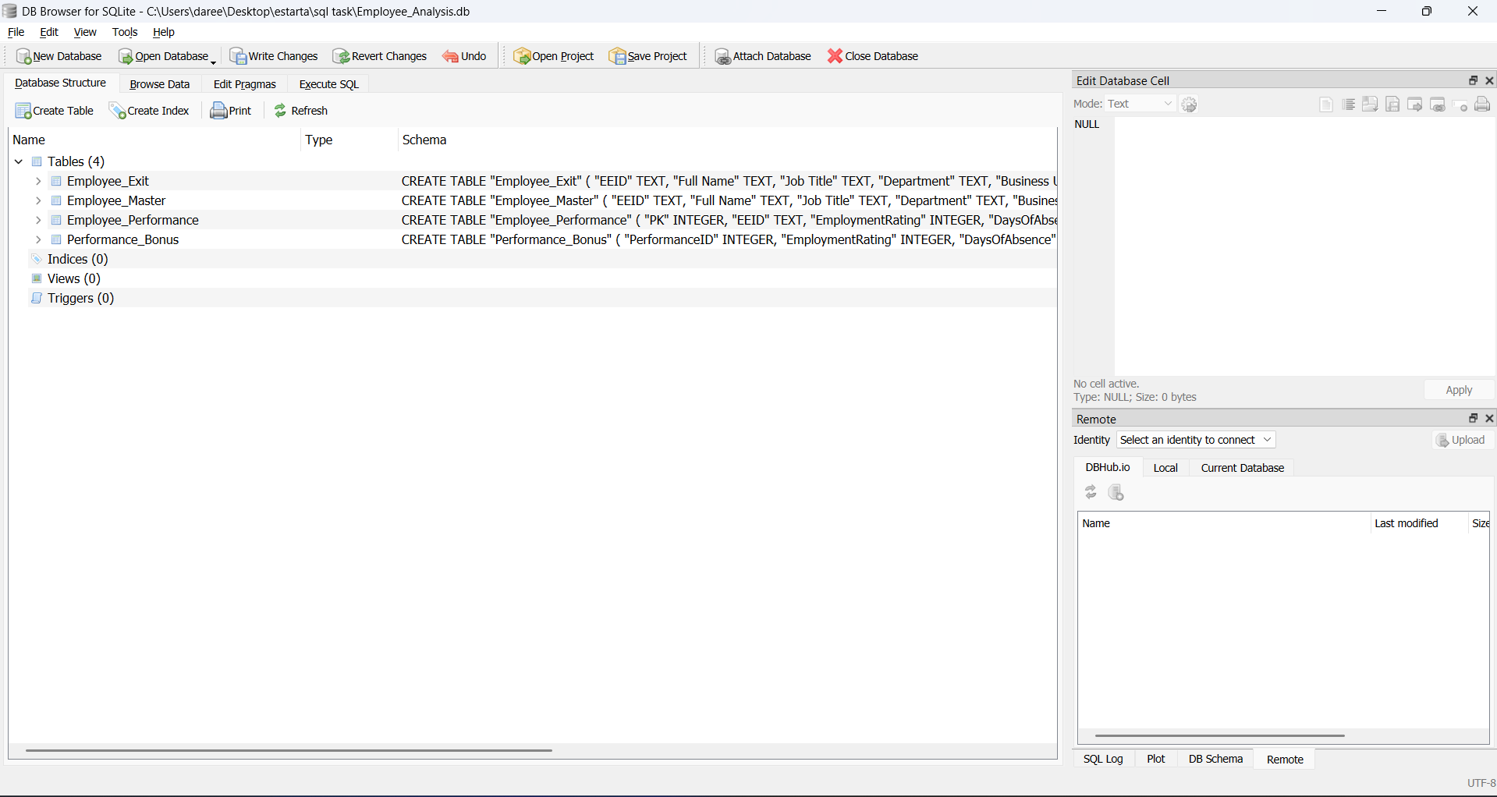
I used sqlite as my database and sqlite browser as the interface:
Figure 1: load data

Know your data:
  - Count total rows in employee:
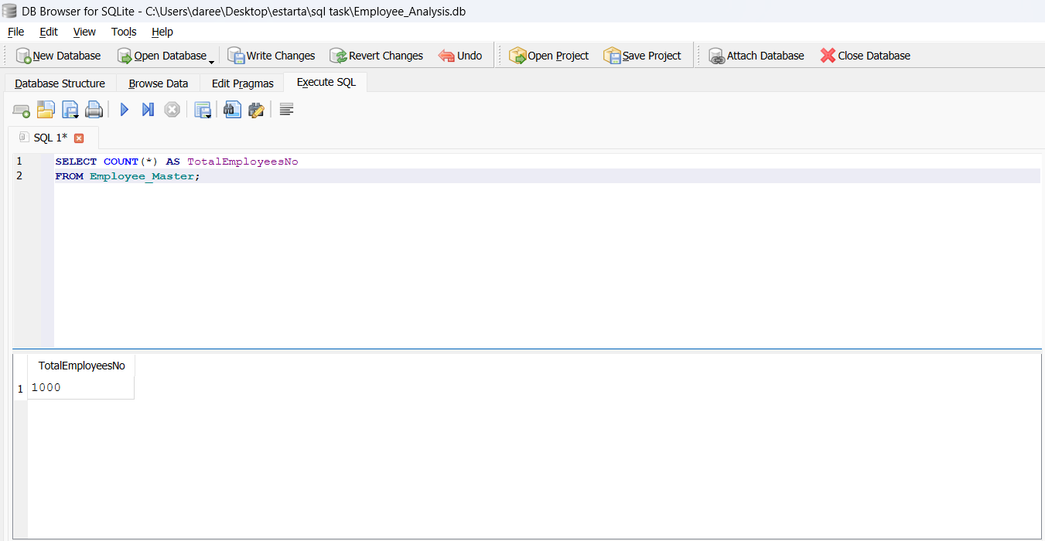
TotalEmployeesNo = 1000
Figure 2: total employees no.
  - Count rows per Department:
I have found that 2 employees are not listed for a department and the highest number of employees are under the IT department
SELECT Department, COUNT(*) AS EmployeesCount
FROM Employee_Master
GROUP BY Department
ORDER BY EmployeesCount;
Table 1: rows count per dept
 | 2
Accounting | 96
Finance | 120
Marketing | 120
Human Resources | 124
Sales | 140
Engineering | 158
IT | 240

  - Count how many nulls appear in ExitDate:
I found 915 null record that means that 915 employees are still working
SELECT COUNT(*) AS ActiveEmployees
FROM Employee_Master
WHERE "Exit Date" IS NULL;
Table 2: null count in exitdate

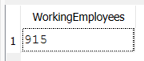
  - Age range of employees:
SELECT MIN(Age) AS MinAge, MAX(Age) AS MaxAge FROM Employee_Master;
Table 3: age range

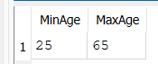

  - Days of Absence:
SELECT AVG(DaysOfAbsence) AS AvgAbsence FROM Employee_Performance;
Table 4: avg absence
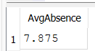

Merge tables:
CREATE TABLE Employee_Profile AS
SELECT
table1.*,table2.EmploymentRating,table2.DaysOfAbsence,table2.EducationLevel,table2.CertificationsEarned
FROM
Employee_Master AS table1
INNER JOIN
Employee_Performance AS table2 ON table1.EEID = table2.EEID;

- Here I have found that there is multiple duplicated EEID in both tables so I dropped from the employee_master duplicates and kept first occurrence and kept the highest rating from employee_preformance

Insert sample records:
INSERT INTO Employee_Profile (EEID, "Full Name", "Job Title", Department, Gender, Age, "Annual Salary", "Bonus %", Country, City, "Exit Date", EmploymentRating, DaysOfAbsence, EducationLevel, CertificationsEarned)
VALUES
('E1001', 'Dareen Fawwaz', 'Senior Developer', 'IT', 'Female', 20, 135000.00, 0.20, 'Jordan', 'Amman', NULL, 5, 2, 'Master', 3);
INSERT INTO Employee_Profile (EEID, "Full Name", "Job Title", Department, Gender, Age, "Annual Salary", "Bonus %", Country, City, "Exit Date", EmploymentRating, DaysOfAbsence, EducationLevel, CertificationsEarned)
VALUES
('E1002', 'Ahmad Ahmad', 'Financial Analyst', 'Finance', 'Male', 27, 85000.00, 0.08, 'Canada', 'Toronto', NULL, 3, 7, 'Bachelor', 1);
INSERT INTO Employee_Profile (EEID, "Full Name", "Job Title", Department, Gender, Age, "Annual Salary", "Bonus %", Country, City, "Exit Date", EmploymentRating, DaysOfAbsence, EducationLevel, CertificationsEarned)
VALUES
('E1003', 'Mohammad Mohammad', 'HR Assistant', 'HR', 'Male', 23, 55000.00, 0.00, 'USA', 'Phoenix', NULL, 3, 10, 'Associate', 0);
INSERT INTO Employee_Profile (EEID, "Full Name", "Job Title", Department, Gender, Age, "Annual Salary", "Bonus %", Country, City, "Exit Date", EmploymentRating, DaysOfAbsence, EducationLevel, CertificationsEarned)
VALUES
('E1004', 'Sara Ahmad', 'IT Support Specialist', 'IT', 'Female', 45, 95000.00, 0.10, 'USA', 'Phoenix', NULL, 4, 4, 'Master', 2);
INSERT INTO Employee_Profile (EEID, "Full Name", "Job Title", Department, Gender, Age, "Annual Salary", "Bonus %", Country, City, "Exit Date", EmploymentRating, DaysOfAbsence, EducationLevel, CertificationsEarned)
VALUES
('E1005', 'Maria Rami', 'Marketing Specialist', 'Marketing', 'Female', 30, 70000.00, 0.05, 'Mexico', 'Mexico City', NULL, 2, 20, 'Bachelor', 1);
INSERT INTO Employee_Profile (EEID, "Full Name", "Job Title", Department, Gender, Age, "Annual Salary", "Bonus %", Country, City, "Exit Date", EmploymentRating, DaysOfAbsence, EducationLevel, CertificationsEarned)
VALUES
('E1006', 'Dalia Ahmad', 'Sales Director', 'Sales', 'Male', 52, 160000.00, 0.30, 'UK', 'London', NULL, 4, 3, 'Master', 3);
INSERT INTO Employee_Profile (EEID, "Full Name", "Job Title", Department, Gender, Age, "Annual Salary", "Bonus %", Country, City, "Exit Date", EmploymentRating, DaysOfAbsence, EducationLevel, CertificationsEarned)
VALUES
('E1007', 'Tala Mohammad', 'Data Scientist', 'IT', 'Female', 29, 110000.00, 0.15, 'Germany', 'Berlin', '2025-01-15', 5, 0, 'PhD', 2);
INSERT INTO Employee_Profile (EEID, "Full Name", "Job Title", Department, Gender, Age, "Annual Salary", "Bonus %", Country, City, "Exit Date", EmploymentRating, DaysOfAbsence, EducationLevel, CertificationsEarned)
VALUES
('E1008', 'Rami Ahmad', 'Logistics Coordinator', 'Operations', 'Male', 48, 65000.00, 0.00, 'USA', 'Dallas', NULL, 3, 15, 'Bachelor', 1);
INSERT INTO Employee_Profile (EEID, "Full Name", "Job Title", Department, Gender, Age, "Annual Salary", "Bonus %", Country, City, "Exit Date", EmploymentRating, DaysOfAbsence, EducationLevel, CertificationsEarned)
VALUES
('E1009', 'Lina Rami', 'Treasury Manager', 'Finance', 'Female', 38, 105000.00, 0.12, 'France', 'Paris', NULL, 4, 6, 'Master', 0);
INSERT INTO Employee_Profile (EEID, "Full Name", "Job Title", Department, Gender, Age, "Annual Salary", "Bonus %", Country, City, "Exit Date", EmploymentRating, DaysOfAbsence, EducationLevel, CertificationsEarned)
VALUES
('E1010', 'Alia Ahmad', 'Junior DevOps', 'IT', 'Male', 24, 68000.00, 0.05, 'USA', 'Phoenix', NULL, 4, 5, 'Bachelor', 1);

Conditional update:
UPDATE Employee_Profile
SET City = 'Abu Dhabi'
WHERE
City = 'Phoenix'
AND Gender = 'Male'
AND Department = 'IT';
Table 5: city equal “Abu Dhabi”
E00523 | Daniel Jordan | Network Administrator | IT | Corporate | Male | Caucasian | 58 | 7/26/1993 | $69,260 | 0 | United States | Abu Dhabi |  | 8 | 15 | Bachelor's | 3
E01722 | Asher Huynh | Manager | IT | Manufacturing | Male | Asian | 45 | 1/22/2015 | $101,288 | 0.1 | United States | Abu Dhabi |  | 10 | 9 | Bachelor's | 4
E1010 | Alia Ahmad | Junior DevOps | IT |  | Male |  | 24 |  | 68000.0 | 0.05 | USA | Abu Dhabi |  | 4 | 5 | Bachelor | 1

Export CSVs:
First check departments in table the result is equal 10 departments:
SELECT DISTINCT Department FROM Employee_Profile;
Table 6: departments
IT
Finance
Sales
Accounting
Human Resources
Engineering
Marketing
NULL
HR
Operations

then I proceeded with this query for every department and exported it into an CSV file and merged the HR and Human Resources and filled the null department with “Unassigned”:
SELECT * FROM Employee_Profile WHERE Department = 'IT';

Part B: Python and ML:

Prepare the IT dataset:
- Load csv file:
df_it = pd.read_csv("Employee_Profile_IT.csv")
- Drop the original ExitDate column:
df_it = df_it.drop(columns=['Exit Date'])
- Clean and process the data:

Figure 3: null records

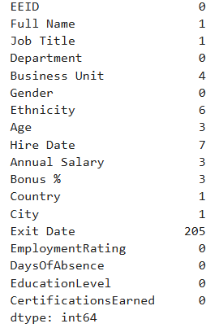
- I dropped records where a string is missing and for the numerical columns I filled null values with median for age, annual salary and bonus and with mode for business unit, ethnicity and hire date
- I created an education_map to convert the education level into an numerical value to use in training our machine and named the column educationlevel_encoded

Exit-Date Prediction:

